Extended Data Figures.
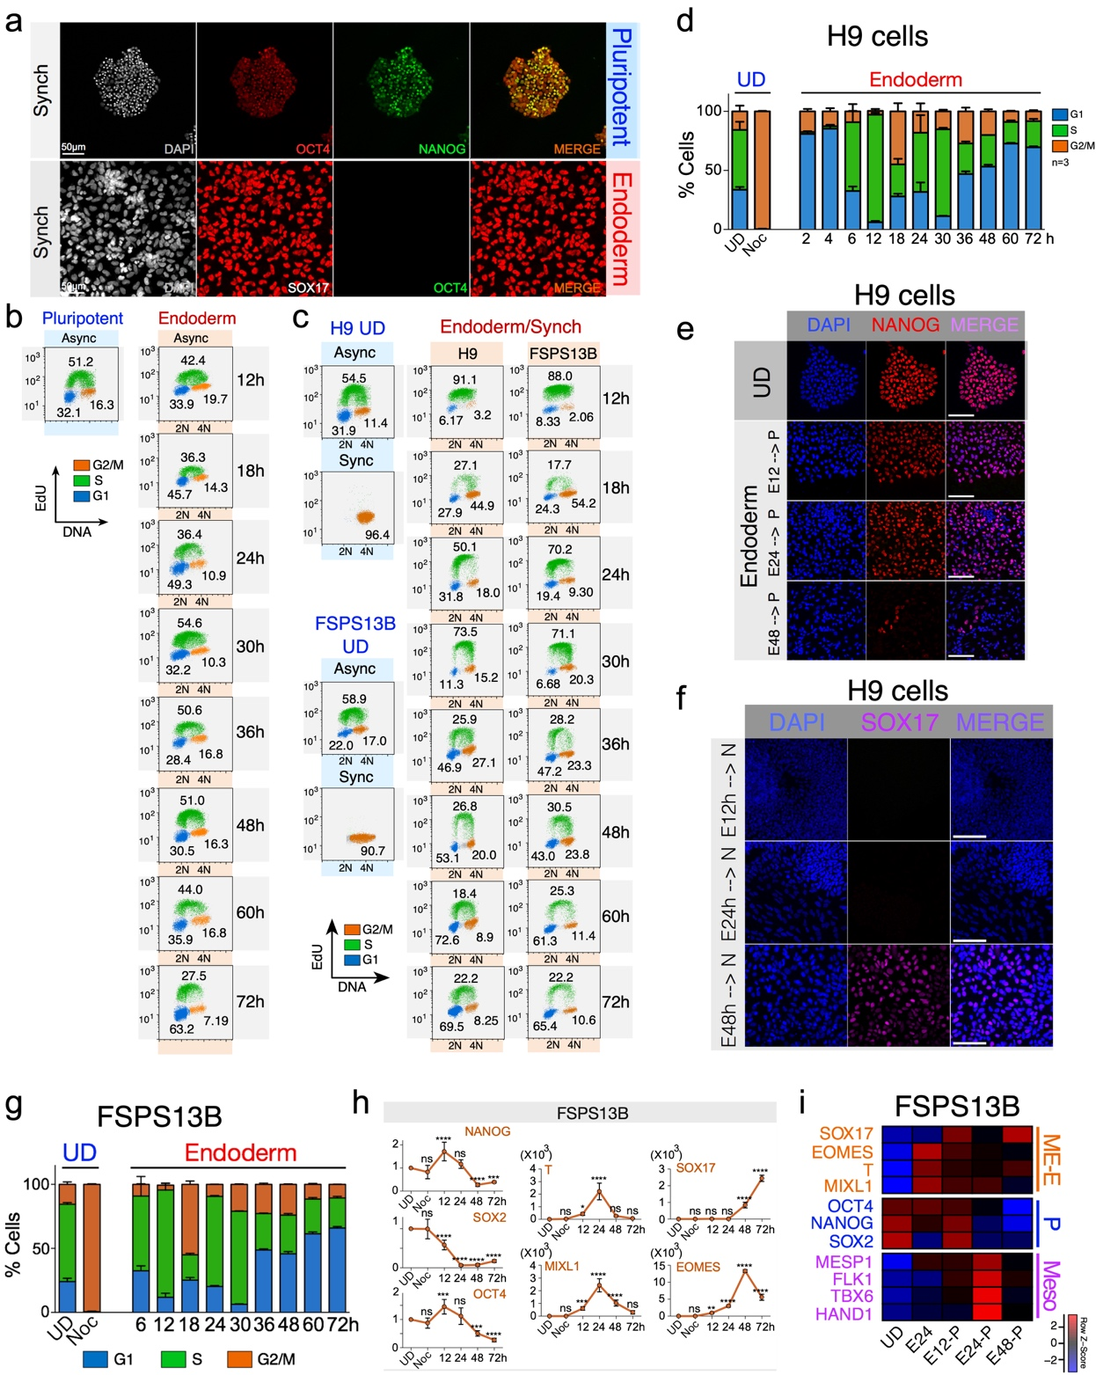

Extended Data Figure 1. Cell division marks cell fate commitment and acquisition of a new cell identity. a) Immunofluorescence of DE cells derived from nocodazole-synchronized hESCs. b) Representative cell cycle profiles of hESCs (H9 cells) during DE differentiation. Flow cytometry analysis of EdU incorporation from cells that have not been synchronized (Asynch). Cells were induced to differentiate following the protocol depicted in fig. 1a. EdU was added to the medium 1h before collecting the cells for the flow cytometry analysis. c) Representative cell cycle profiles of human pluripotent cells (H9 and FSPS13B cells) during DE differentiation. Flow cytometry analysis of EdU incorporation from nocodazole-synchronized cells (Synch). Cells were synchronized with nocodazole for 16h and induced to differentiate following the protocol depicted in fig. 2a. EdU was added to the medium 1h before collecting the cells for the flow cytometry analysis. d) Bar plot summarizes data obtained from flow cytometry analysis of EdU incorporation in H9 cells. Numbers inside the box represent the averaged percentage of cells found at each cell cycle phase during the time course experiment (n=3). e) Immunofluorescence analysis of cells treated as described in Figure 2d. Cells were Synchronized at G2/M, then released into DE-induction medium. At the specified time points, cells were put back into pluripotency medium (P: E8 medium) for another 48h. f) Immunofluorescence analysis of cells treated as described in Figure 2f. Cells were Synchronized at G2/M, then released into DE-induction medium. At the specified time points, cells were put back into Neuroectoderm medium for another 4 days. g) Bar plot summarizes data obtained from flow cytometry analysis of EdU incorporation in FSPS13B cells. Numbers inside the box represent the averaged percentage of cells found at each cell cycle phase during the time course experiment (n=3). h) RNA expression profiles of genes critical for DE formation. Data represent the average of three different experiments obtained from FSPS13B cells. Statistical significance was assessed by performing multiple comparisons using One-Way ANOVA (n=3; ns, p > 0.05; **, p≤0.01; ***, p≤0.001 ****, p≤0.0001). i) RNA expression levels were assessed by qPCR and plotted as heat maps. Results obtained from FSPS13B cells treated as described in Fig. 2d. Heat maps show the z-scores of the average log2 fold change obtained from three independent experiments. UD: Undifferentiated, E12-P: 12h of endoderm differentiation, then cells were put back into pluripotency medium for 48h; E24-P: 24h of endoderm differentiation, then cells were put back into pluripotency medium for 48h; E48-P: 48h of endoderm differentiation, then cells were put back into pluripotency medium for 48h.

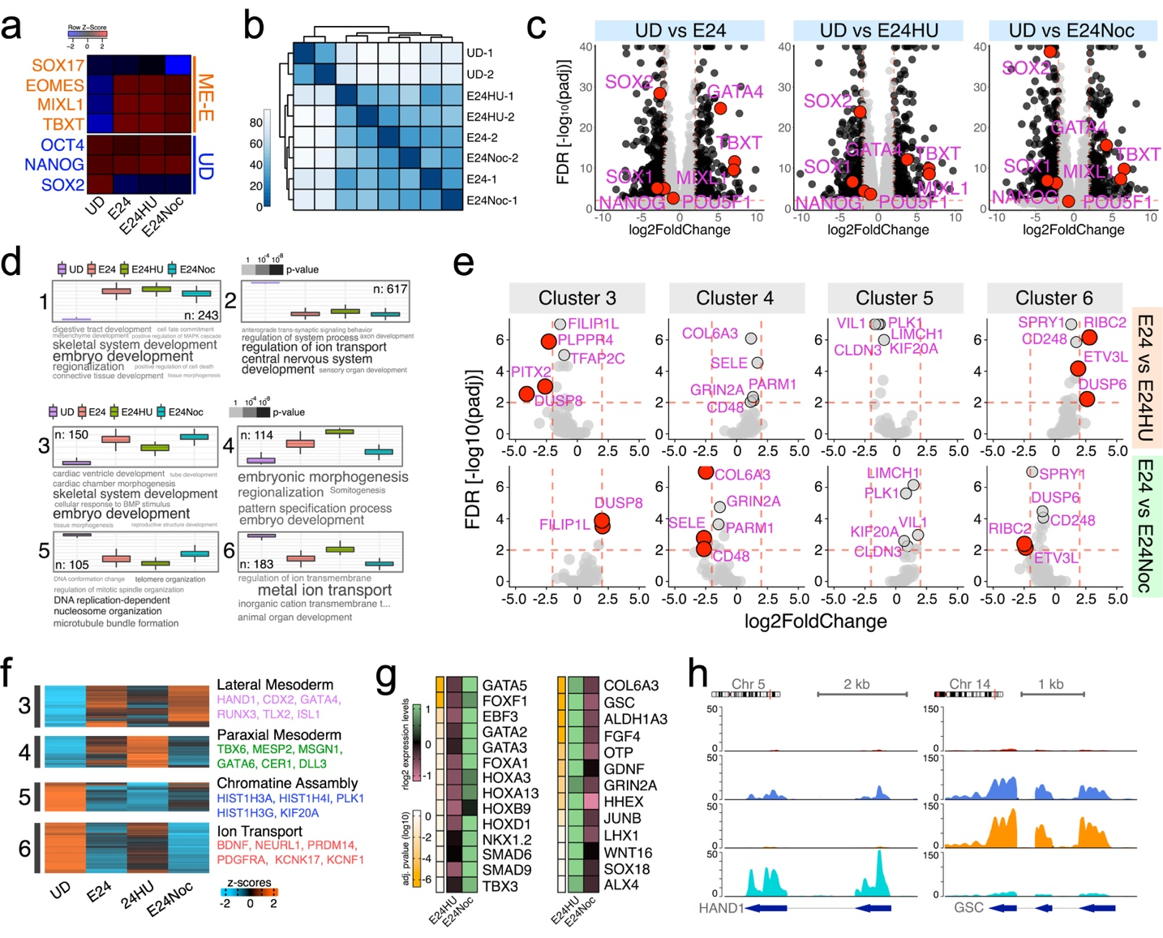

Extended Data Figure 2. Cell Division is not Required for the Epigenome Remodeling and Transcriptional Activation Associated to Cell Differentiation. a) qPCR analysis of key genes for cells treated as in fig.3b. Heatmap shows the z-scores of the average log2 fold change obtained from three independent experiments. b) Sample correlation matrix displaying the overall similarity in expression profile among different samples and biological replicates. c) Volcano plots of differentially expressed genes between UD vs. E24, UD vs. E24HU, and UD vs. E24Noc. Dark dots represent the most significant differentially expressed genes (p-adj ≤ 0.01, FDR 1%, |log2FC ≥ 2|). Red dots highlight key genes important to sustain pluripotency or induce ME differentiation. Note the similar pattern of expression of these genes among all the different types of ME differentiation. d) GO analysis of genes associated to clusters 3-6. Bar plots represent the average gene expression in each cluster among different culture conditions. GO terms are present as word clouds. In the word clouds the size of the words is proportional to -log10 of enrichment p-value within the word cloud. The absolute enrichment strength of terms (words) is color-coded in grayscale. e) Volcano plots of differentially expressed genes among the ME samples for cluster 3-6: E24 vs. E24HU, and E24 vs. E24Noc. Red dots highlight genes that passed the differential expression threshold (p-adj ≤ 0.01, FDR 1%, |log2FC ≥ 2|). Note that most genes within these clusters failed to pass the significance threshold. f) Heatmap of the RNA-seq levels of differentially expressed genes between undifferentiated (UD) vs. ME samples (UD vs. E24, UD vs. E24HU, and UD vs. E24Noc; log2 |FC ≥2|, FDR ≤ 0.01, n = 2). Only clusters 3-6 are displayed. g) Heatmap of the RNA-seq levels of genes find in clusters 3 and 4 after calculating differential expression among ME samples: E24 vs. E24HU, E24 vs. E24Noc; log2 |FC ≥2|, FDR ≤ 0.01, n = 2). Genes were order by their adjusted p values (Yellow Key). Top 14 most significant differentially expressed genes are displayed. h) RNA expression coverage tracks for two of the most differentially expressed genes in cluster 3 (HAND1) or cluster 4 (GSC). Plots show the normalized reads per genome coverage. Red track: UD; Blue track: E24; Orange track: E24HU; Cyan track: E24Noc.

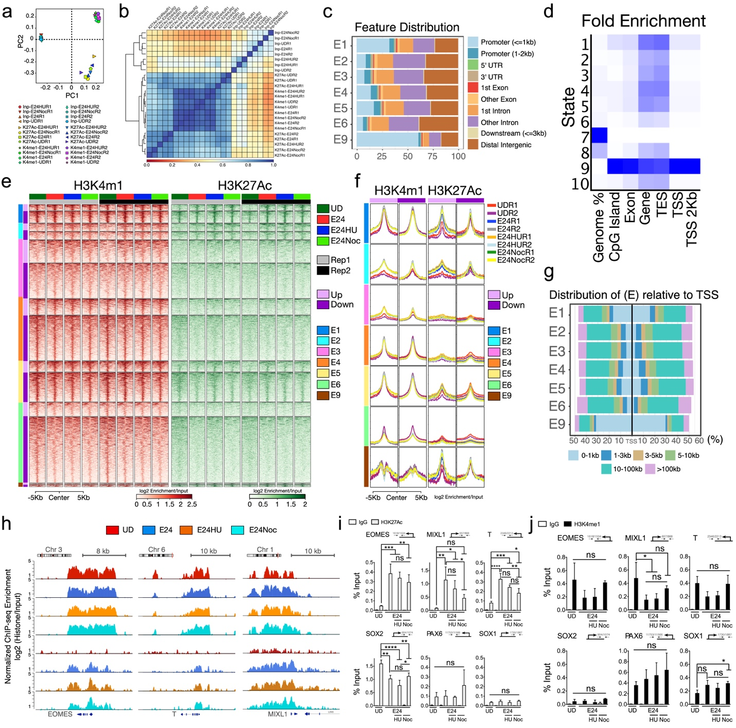

Extended Data Figure 3. Cell Division is not Required for the Epigenome Remodeling and Transcriptional Activation Associated to Cell Differentiation. a) Principal component analysis plot of the read coverage values for each sample. Loadings of the first two components are displayed. b) Heatmap of the read coverage correlation of values for each sample. Colors represent the pairwise correlation coefficients and the dendrogram is product of hierarchical clustering. c) Feature distribution plot represents the allocation of genomic elements in each chromatin state (E) identified by the ChromHMM algorithm. The x axis displays the percentage of features in each state. d) Heatmap of the overlap fold enrichment for various external genomic annotations (TSS: transcriptional start site, TES: transcriptional end site). A darker blue color corresponds to a greater fold enrichment for a column-specific coloring scale. e) Heatmap of ChIP-seq enrichment over input for samples generated as described in fig. 3b. Both biological replicates are included. f) ChIP-seq average enrichment over input of each histone mark was calculated for selected states, which were annotated to the closest gene and segregated based on level of expression. Both biological replicates are displayed. g) Distribution and distance of the chromatin states (E) identified by the ChromHMM algorithm in relation with the TSS of genes. h) Coverage track of histone modifications for three key gene markers involved in Mesendoderm differentiation (EOMES, TBXT, and MIXL1). Plots show the log2 ration of RPKM over input. i) ChIP-qPCR analysis of the H3K27Ac enrichment at genomic regions close to key transcription factors involved in either maintaining pluripotency (SOX2), ME differentiation (EOMES, TBXT, MIXL1) or Neuro-ectoderm (PAX6 and SOX1). Statistical significance was assessed by performing multiple comparisons using One-Way ANOVA (n=3; ns, p > 0.05; **, p≤0.01; ***, p≤0.001 ****, p≤0.0001). j) Similar to I but for H3K4me1.

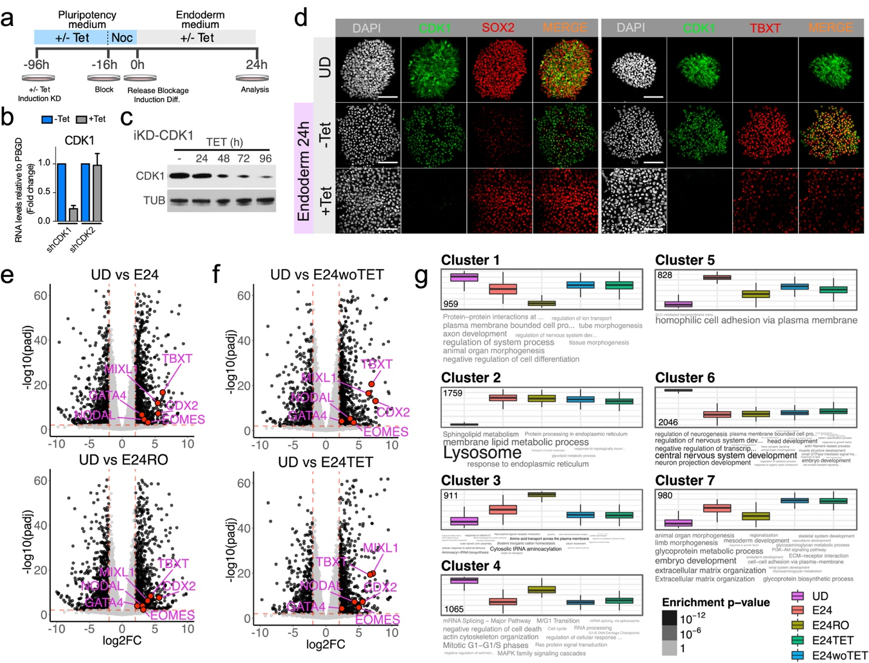

Extended Data Figure 4. The Cell Cycle Regulator CDK1 controls the Acquisition of a New Cell Identity During Differentiation. a) Schematic representation of the experimental conditions used to assess the role of the cell cycle regulator CDK1 during differentiation. b) qPCR analysis of the CDK1 gene expression in undifferentiated hESCs before or after the expression of inducible shRNAs against CDK1 or a completely unrelated shRNA (shCDK2). -TET: without the inductor tetracycline; +TET: in presence of the inductor tetracycline c) Immunoblot assay shows the effectiveness of the shRNA to reduce the protein levels of CDK1. Cells were treated with tetracycline (TET) for the time indicated (h) before samples were collected and processed. TUB: Tubulin. d) Immunofluorescence analysis of key markers in cells treated as described in a. e,f) Volcano plots for the differential RNA expression levels obtained in undifferentiated hESCs (UD) or ME cells (E24), in absence or presence of CDK1 function. E24RO: Cell differentiated into ME in presence of the CDK1 inhibitor RO3306; E24woTET: Cells carrying the inducible vector for expression of shRNA against CDK1 were differentiated in absence of the inductor tetracyclin; E24TET: Cells carrying the inducible vector for expression of shRNA against CDK1 were differentiated in presence of the inductor tetracyclin. Black dots highlight genes that passed the differential expression threshold (p-adj ≤ 0.01, FDR 1%, |log2FC ≥ 2|). g) GO analysis for differentially described in e and f. Genes were clustered by k-mean and the resulting groups were subjected to biological function enrichment analysis. Bar plots represent the average gene expression in each cluster among different culture conditions. GO terms are present as word clouds. In the word clouds the size of the words is proportional to -log10 of enrichment p-value within the word cloud. The absolute enrichment strength of terms (words) is color-coded in grayscale.

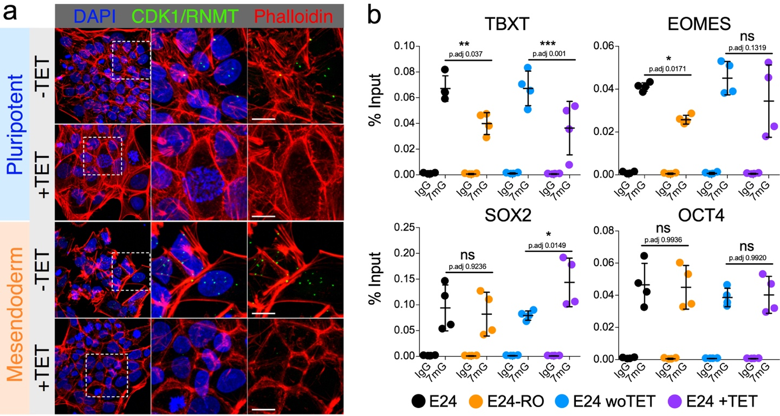

Extended Data Figure 5. The Cell Cycle Regulator CDK1 interacts with the RNMT protein and controls the RNA-m7G Deposition on Key Genes During Differentiation. a) Proximity ligation assays (PLA) for CDK1 and RNMT proteins in undifferentiated hESCs (Pluripotent) or Mesendoderm differentiated cells (ME). -TET: absence of tetracycline implies normal levels of CDK1. +TET: in presence of tetracycline, implies CDK1 knock down. (representative of 3 experiments). Scale bars, 10μm. DAPI, nuclei. b) qPCR analysis of the levels of 7mG modifications on a set of specific transcripts as determined by RNA-IP assays in ME cells in presence or absence of CDK1 function. E24: Cell differentiated toward the ME lineage in normal condition where CDK1 is completely functional; E24RO: Cell differentiated toward the ME lineage in presence of the CDK1 inhibitor RO3306; E24woTET: Cells carrying the inducible vector for expression of shRNA against CDK1 were differentiated in absence of the inductor tetracyclin; E24TET: Cells carrying the inducible vector for expression of shRNA against CDK1 were differentiated in presence of the inductor tetracyclin. Statistical significance was assessed by performing multiple comparisons using One-Way ANOVA (n=2; ns, p > 0.05; *, p≤0.05; **, p≤0.01; ***, p≤0.001).

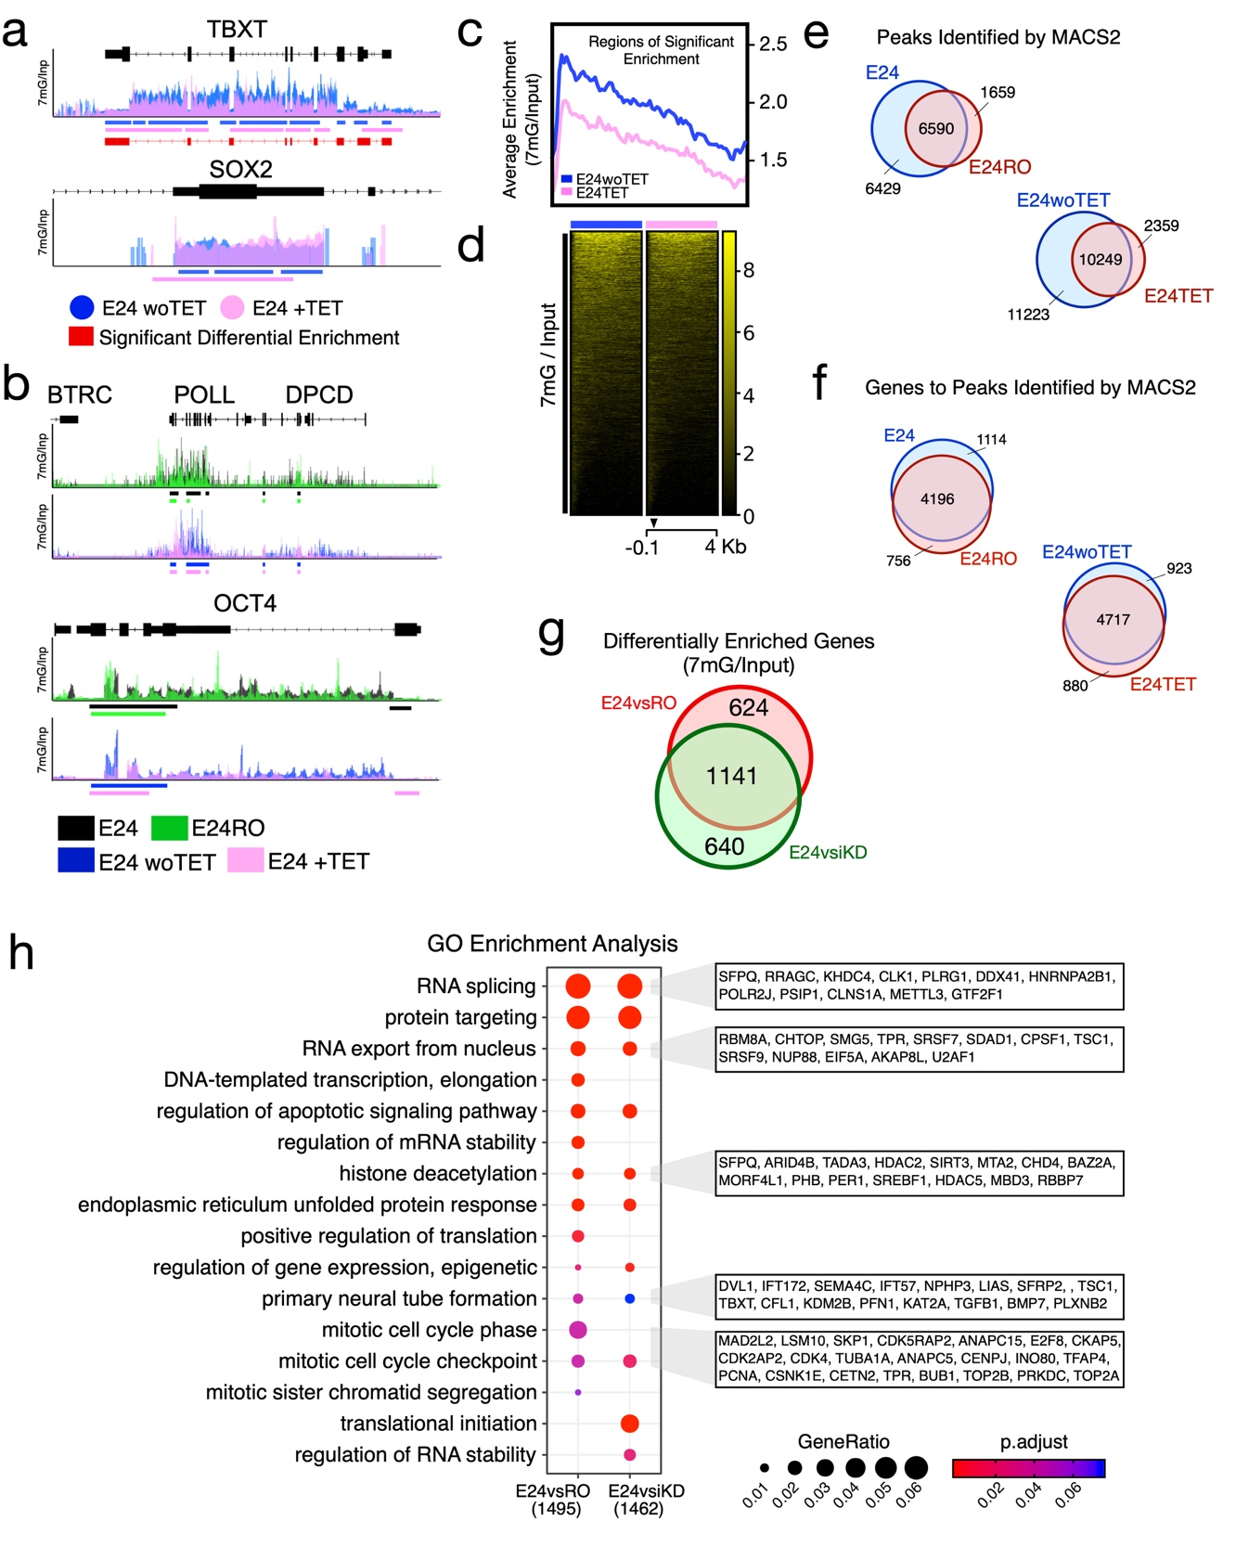Extended Data Figure 6. The Cell Cycle Regulator CDK1 controls the Acquisition of a New Cell Identity During Differentiation by Modulating RNA-m7G Deposition on Key Genes During Differentiation. a) RNA-IP coverage tracks for two key gene markers of either pluripotency (SOX2) or Mesendoderm (TBXT). Cells were differentiated towards the ME lineage in the presence (E24woTET) or absence of the CDK1 protein (E24TET). Plots show the overlay of the normalized ratio for 7mG over input. Control (E24woTET) vs treated (E24TET). Red bars represent regions of significant differential enrichment (FDR=0.05). Colored lines under tracks: peaks identified by MACS2. b) Similar to a, RNA-IP coverage tracks for a subset of genes that show no difference in 7mG levels regardless of the CDK1 function status. c) Average enrichment profile of RNA-IPs. Regions of significant enrichment were used to calculate the average enrichment over input of the 7mG. Blue line represents the 7mG enrichment on RNAs obtained during control differentiation (E24woTET). The pink line is the average enrichment for RNAs during CDK1 depleted ME differentiation (E24TET). d) Heatmap of RNA-IP enrichment over input for all the genes with significant enrichment of 7mG. Blue line: E24woTET; Pink line: E24TET. Arrow head: TSS. e) Venn Diagrams show the number of 7mG peaks identified in ME samples generated in the presence or absence of CDK1 function. Peaks were identified by the MACS2 algorithm in individual biological replicates. Only peaks detected in both replicates were used to build the Venn diagram. f) Peaks described in “e” were annotated to the closest gene. These genes were then used to construct Venn diagrams showing the degree of overlap among the genes carrying 7mG modification in ME samples generated in the presence or absence of CDK1 function. g) Venn Diagram shows the number of differentially enriched 7mG peaks identified in ME samples generated in the presence or absence of CDK1 function. After differential enrichment analysis these peaks were annotated to the closest gene. h) GO analysis on genes with significant differential enrichment of 7mG levels in ME cells generated in presence or absence of CDK1 function. The plot shows a comparison of the different biological terms produced by the list of genes whose levels of 7mG were directly affected by the inhibition of CDK1 (E24vsE24RO) or the knocking down of the CDK1 (E24woTETvsE24TET). The boxes on the right contain examples of genes present in some of the most prominent biological terms detected.

